CREATING & SENDING NEWSLETTERS for MAJOR EVENTS

- There are 4 kinds of major events: Career Development Workshops, Career Management Seminars, Trends and Viewpoints (formerly - Evening Program) and Tools and Techniques. The process is the same for all four.
- Each type of event is associated with 3 newsletter: the first one is sent 30 days ahead of the event date or the day after the event is posted (if it is less than 30 days), the second one 10 days ahead of the registration close date, and the third is sent two (or one if the former falls on a weekend) days ahead of the event’s “Last Date to Register Online”.
- Each event is also associated with an attendee email (one day before or on the day of the event), and an attendee survey email (sent one day after the event took place), which are sent to those who have registered for the event only; and an attendee list email (this last one is sent to the event hosts). There is a separate process for sending those three, which is covered in a separate document.
- Every day or on a needed basis, the Communications Manager accesses the PMISV Google calendar and checks whether there are newsletters that need to be sent out that day. The best time to send out a newsletter(s) is at 5:30 am, 11.30 am or 2pm; please avoid sending events all at once, if there are more than one newsletter that needs to be sent on a specific day.

- Log in to the pmisv.org website
- Go to “Administrator” on the right-hand margin.

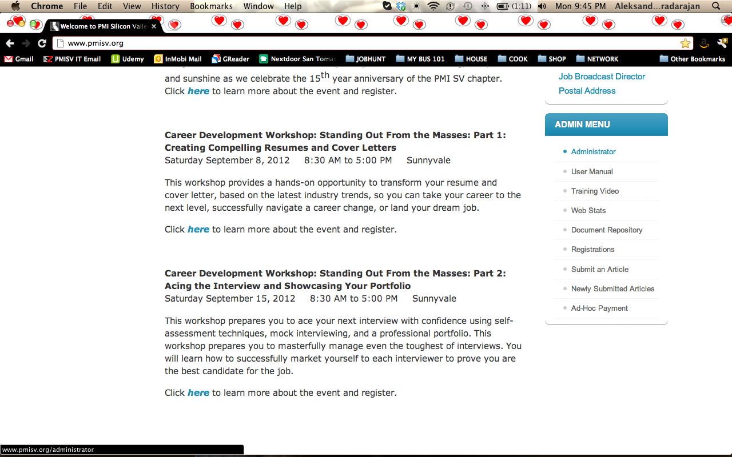
- Login to Joomla using the same credentials, as your chapter website log-in.
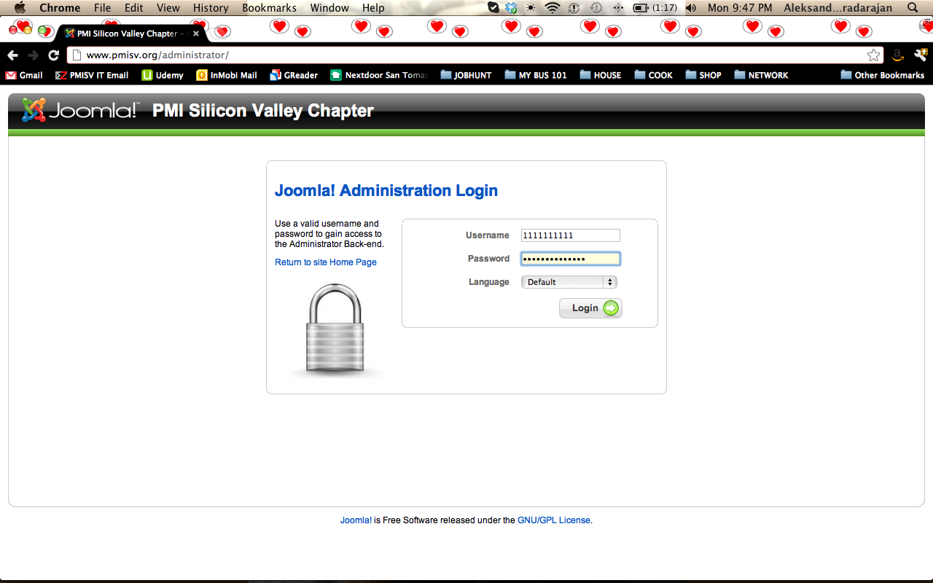

- Go to “Components” >> “JNews” >> “Newsletters”.

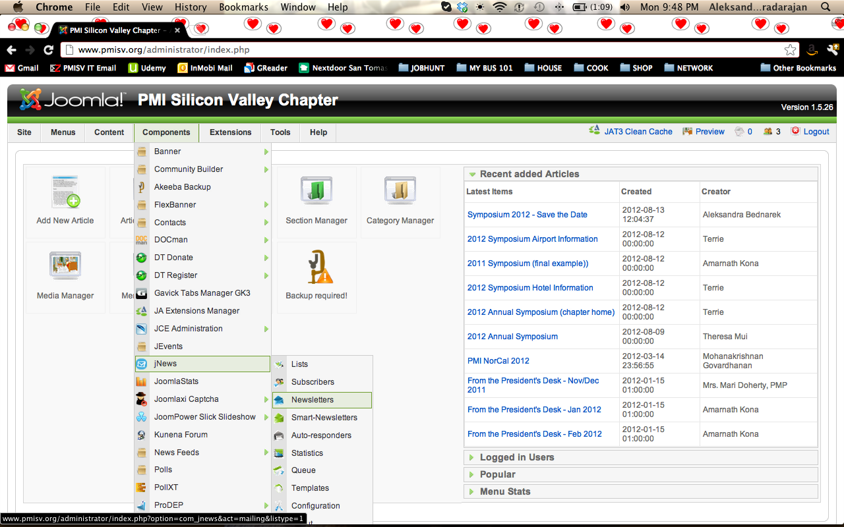

- Click on “New” to start a new newsletter.

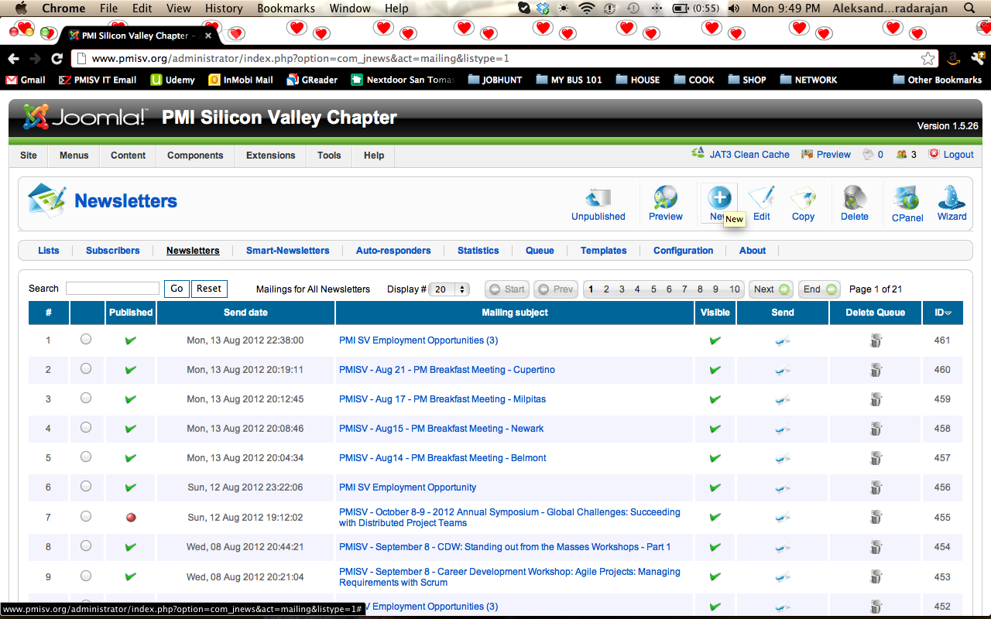

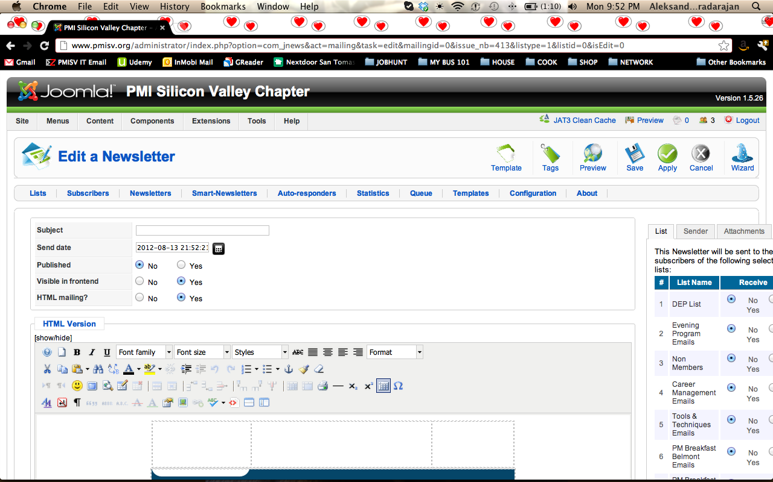
- Add a Subject. The template is:
  - PMISV – January 1 – Career Development Workshop: Event Title
  - PMISV – January 1 – Career Management Seminar: Event Title
  - PMISV – January 1 – Trends and Viewpoints: Event Title
  - PMISV – January 1 – Tools and Techniques: Event Title

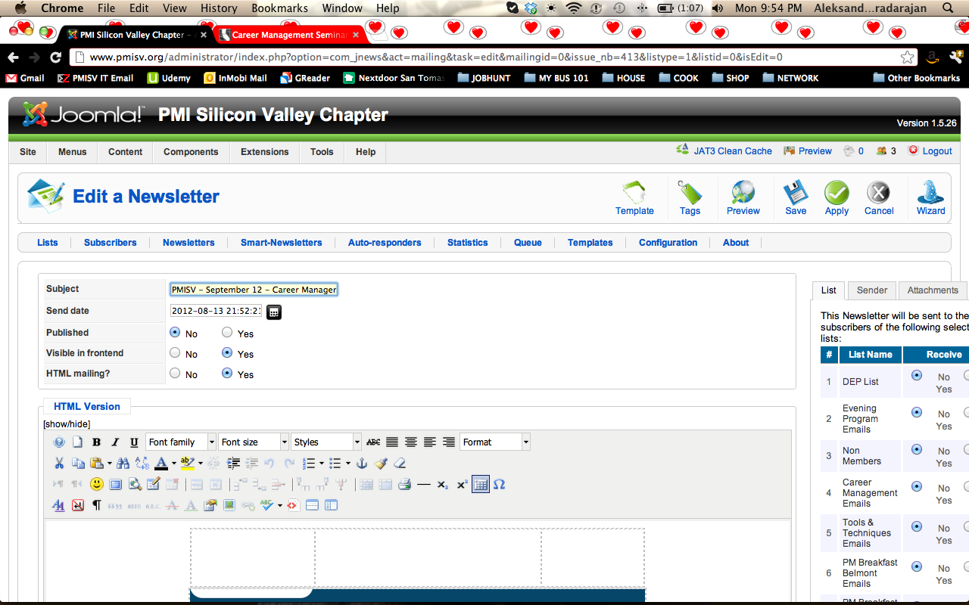

- Put in the date and time (24 hrs format) you want the email to be sent to chapter members. Make sure that “Visible in frontend” and “HTML mailing” are selected as ‘yes’.
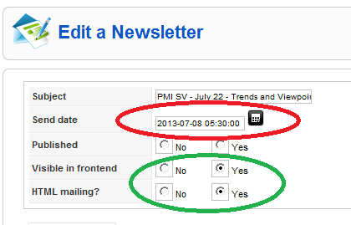

- On the right-hand margin, go to “List” tab and select the mailing list that the event will be sent to (Career Development Workshop for event of the same name, etc.)

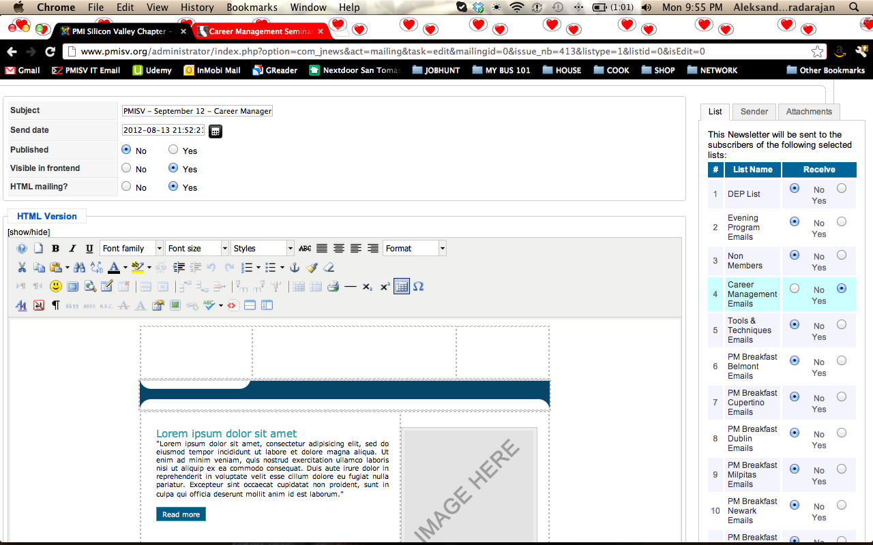

- On the same margin, go to “Sender” tab and change your name to “PMI Silicon Valley Chapter” (No quotation marks); change “Sender Email” and “Respond to Address” to noreply@pmisv.org (no quotation marks).

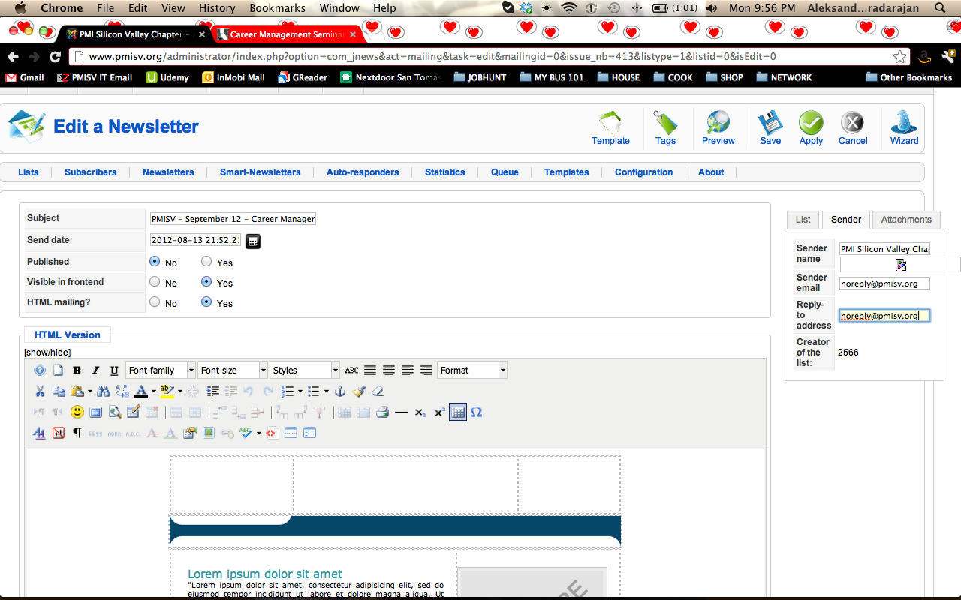

- In the body of the event, select all and clear the window.

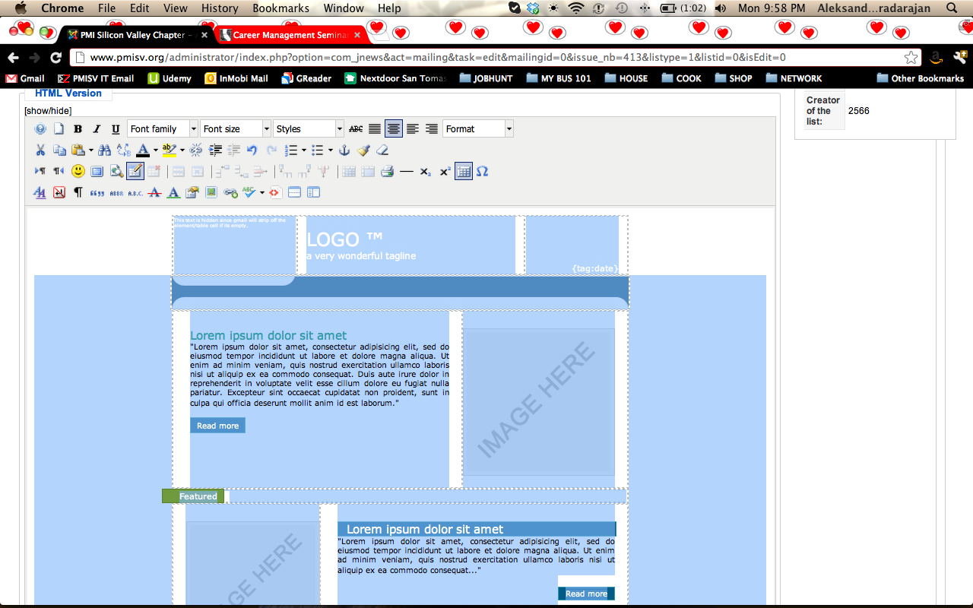
- In another tab of your browser, go to the Calendar on the PMISV website, and to the specific event that you need to create a newsletter for.
- Copy the whole event (without the title and date/time information at the top).

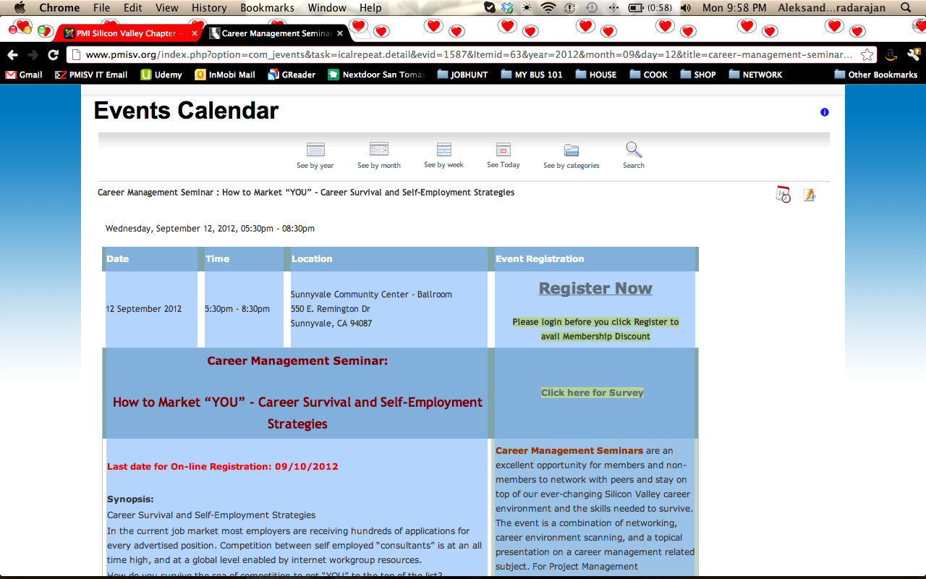

- Go back to the administrator tab and paste the event into the editor window that you just cleared.
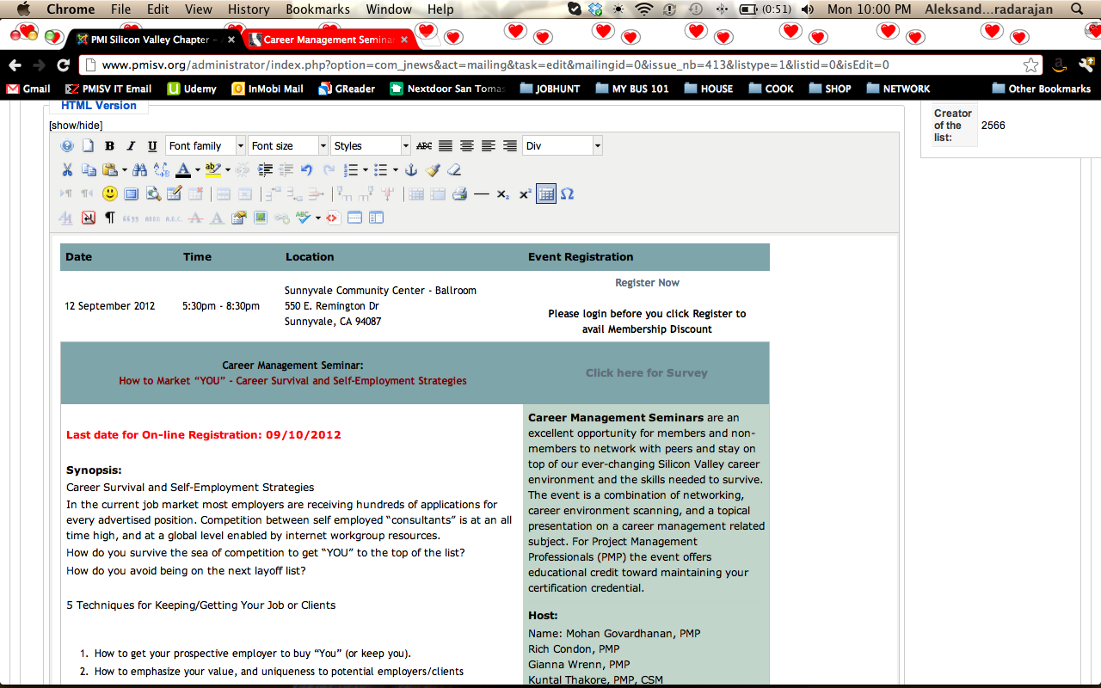

- Adjust formatting to match the one on the website calendar (font used is generally Verdana (font size 8), with a slightly bigger font for the event title). Remember to adjust colors, ad highlights and remove any unnecessary space/extra empty lines etc. that appeared after you had pasted the text.

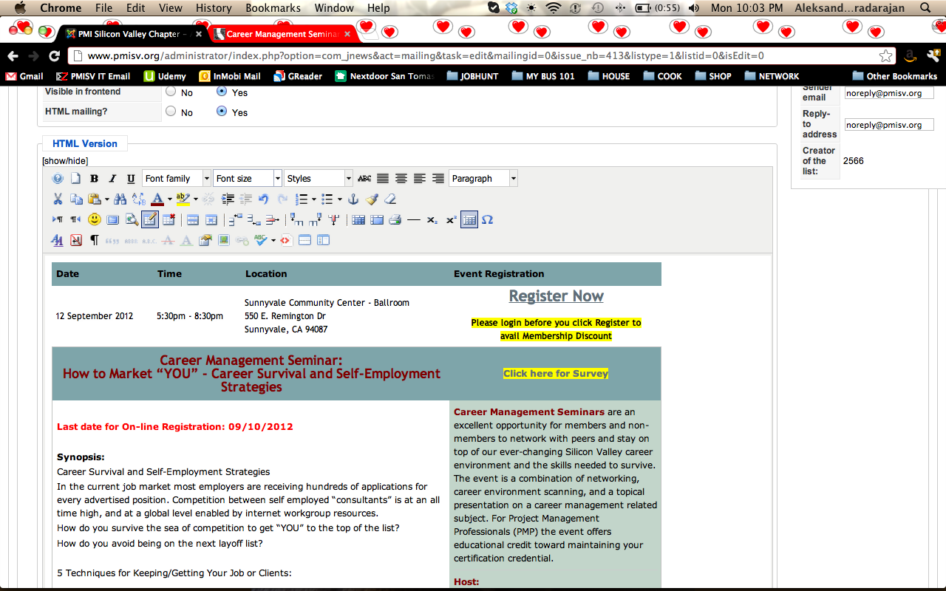

- Click on “Save” and open another existing major event and copy the top banner with the PMISV logo, then go back to the event you were editing and paste it at the top of the event. Remember to “Apply” your changes.

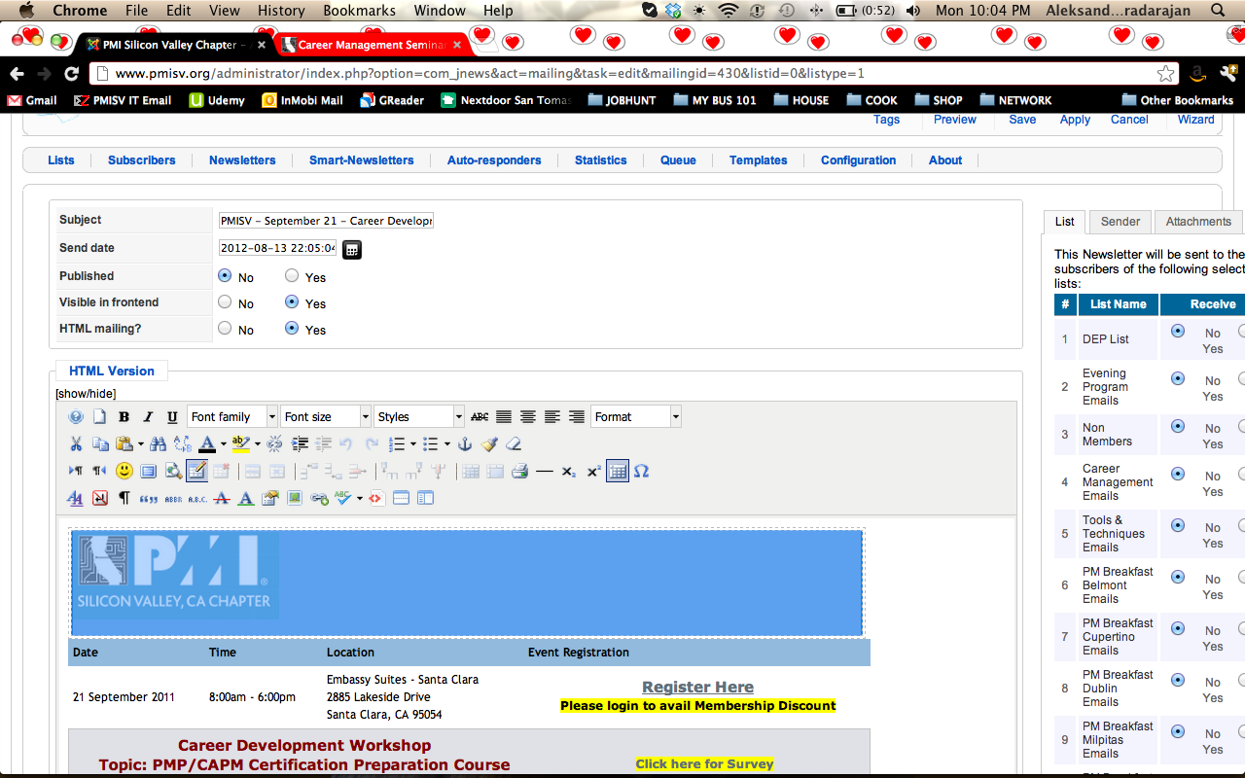

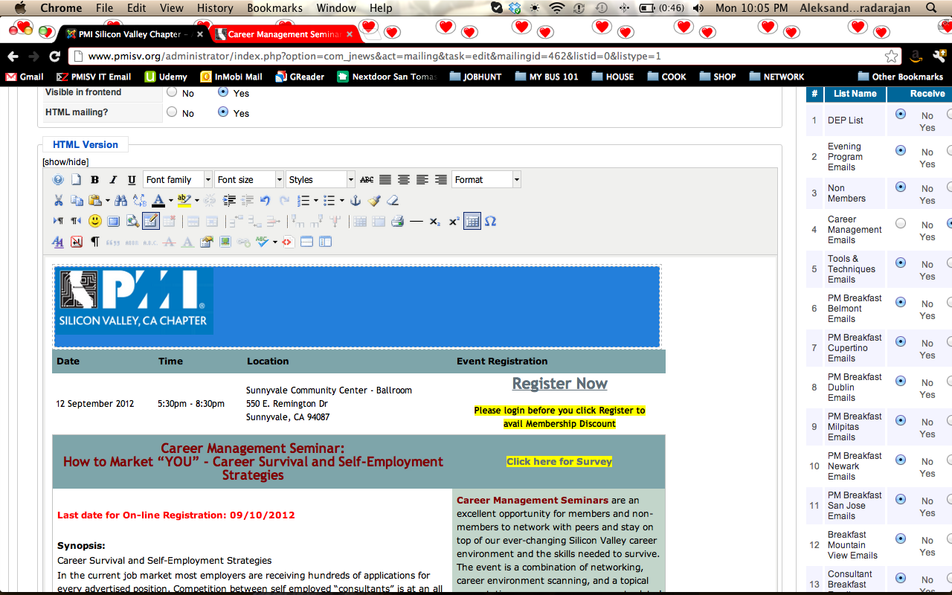

- If there are any bulleted/numbered lists in the body of the event, please remove the bullets/numbers, select the whole list and add the bullets/numbers back using the editor buttons.
- As you proceed, please remember to “Apply” your changes periodically to prevent any accidental loss.
- When done, please go to “Preview” and “Send a Test Email”. This will send a single email to yourself with the newsletter you just created. Open the email and check for any formatting problems, then go back and fix and issues.

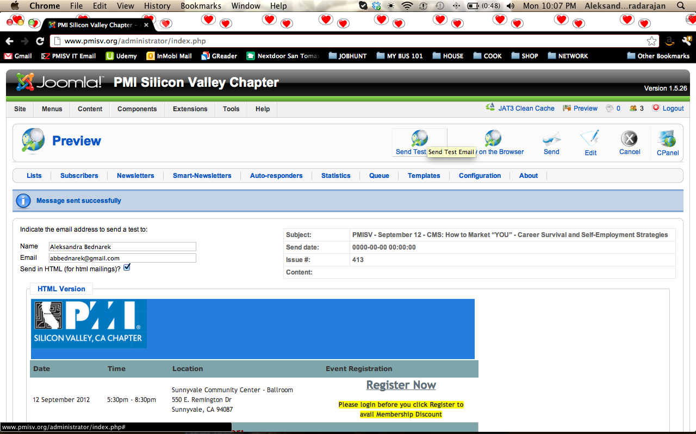

- Click on the “Edit” button, if you are in the preview pane
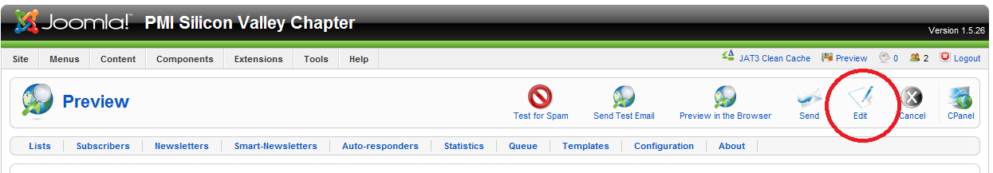
- Then “Save” the newsletter
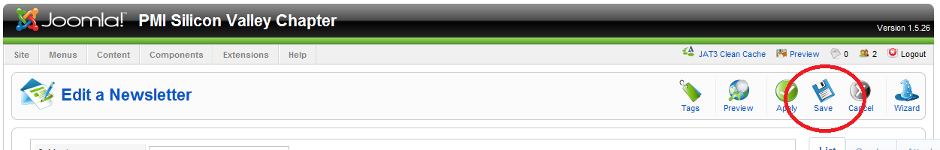

USE THE FOLLOWING STEPS ONLY WHEN AN “URGENT” EMAIL COMMUNICATION IS TO BE SENT TO THE MEMBERS IMMEDIATELY. ALWAYS TRY TO SCHEDULE THE NEWLETTERS / SUBSCRIPTION EMAILS AHEAD OF TIME. (Reason – when mass emailing is done, ISPs take it as spam and block the emails. By scheduling the email, the servers try to send the emails in ‘blocks’)

- When ready, once again go to “Preview” and “Send”, check that the newsletter is being sent to the appropriate mailing list, and confirm by clicking “Send”.

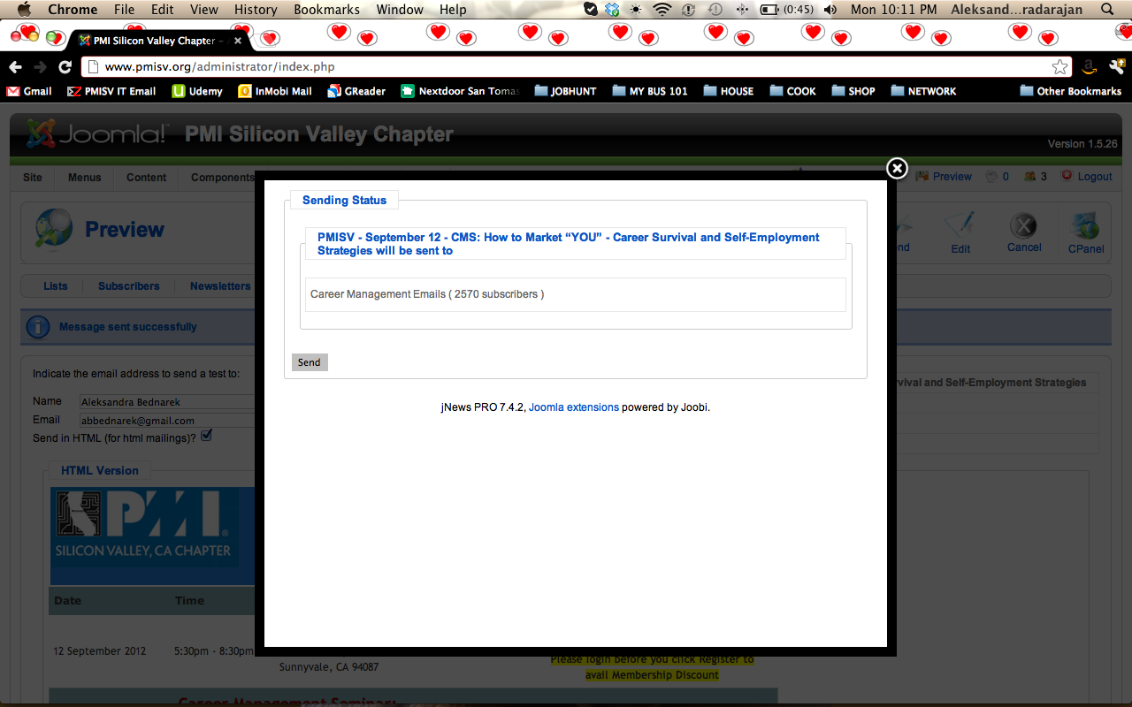

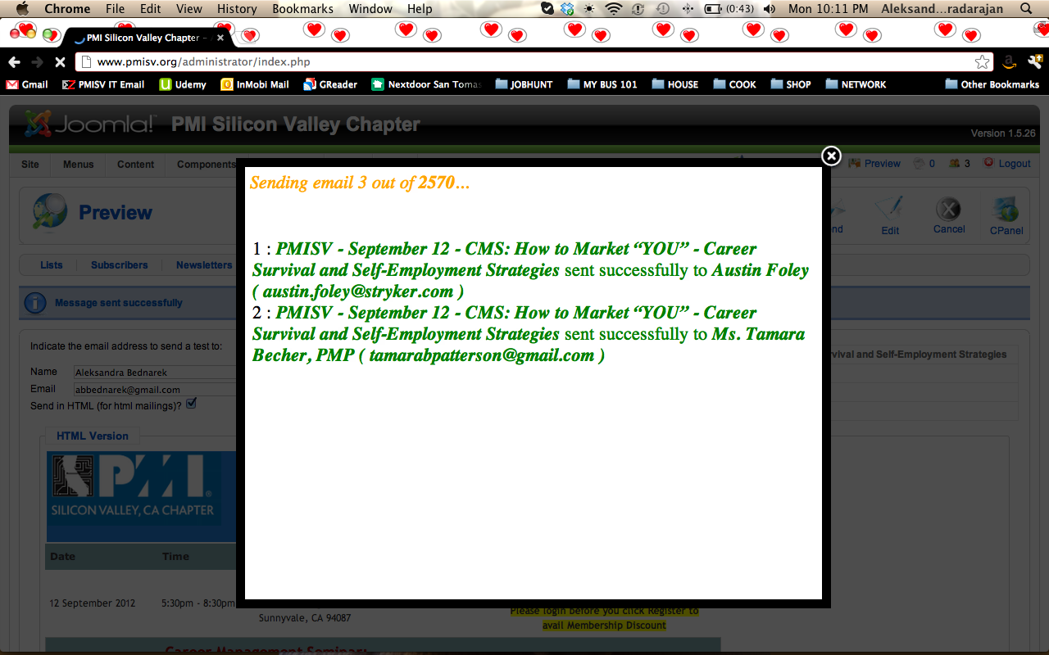

- You are now done, but you will need to keep your laptop open until the newsletter is done being sent out to all of the recipients. This usually takes a few minutes. You will be able to see a message at the bottom of the screen (you need to scroll down) telling you that the newsletter has been sent successfully.

