How to print label
- Download the Name Label template from PMISV - Programs Cabinet page (require login PMISV): “PMISV_Name_Label_Maker.docx” from:
http://www.pmisv.org/index.php?option=com_content&view=article&id=187

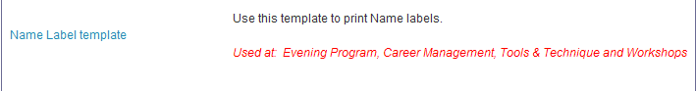
- Open “PMISV_Name_Label_Maker.docx” file
- Select “No” for the following question:
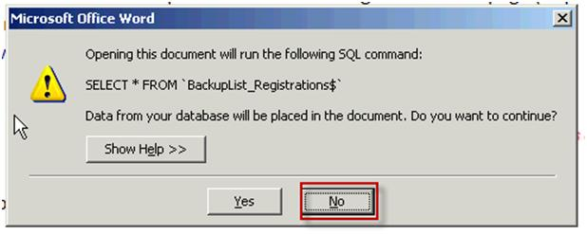
- Under “Mailing” tabClick “Select recipients” icon select “Use existing list” option
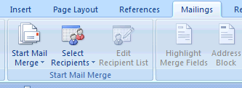

- Select/import the name list file from your file save location
- Click the “Finish & Merge” icon select “edit individual documents”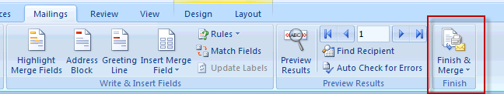

- Click “All”
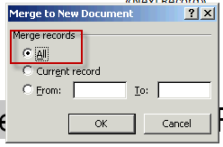

- Another MSWord document will be created with attendees names.
- Print the new created file with PMISV label sheet. Since each printer oriented differently, please use a blank paper to test the side, orientation, and direction before using the expensive PMISV label sheet.

