DOCUMENT UPLOAD IN JOOMLA
- Check if the required “folder” is available under the ‘Components DocMan Categories’ module (e.g. 2014 Symposium under “Special folder / Symposium”)
- If folder is NOT available, click ‘add’ and create required “category” as a sub-folder under appropriate folder.
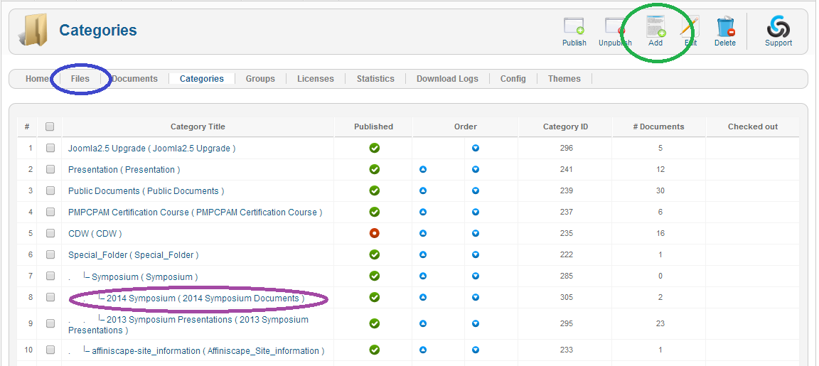

- If the ‘folder / category’ is available then go to ‘Components DocMan Files’ option (or directly click the “Files” link available in the ‘ribbon’ and click on “upload” icon.
- Select “upload a file from your computer” and click ‘next’.
- Choose a file from browsing it from your computer and click ‘submit’.
- You will get an option to ‘Make a new document entry using this file.’
- Click that option
- In the next screen “Add Document”:
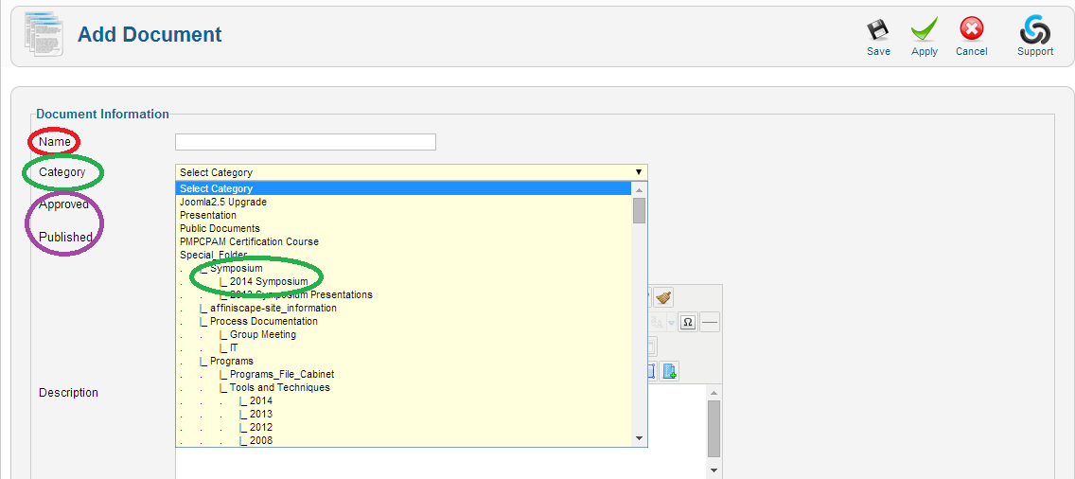
  - Define name (which will appear in the website as the link to the document) e.g. 2014 Symposium venue details
  - Select “Category” e.g. “Special folder / Symposium / 2014 Symposium”
  - Select “Yes” for both Approved and Published.
  - In the section below check and insure that the file name you uploaded is appearing correctly.
  - Click on “save / apply” at the top ribbon to save the document.
- Adding document to the article / webpage:
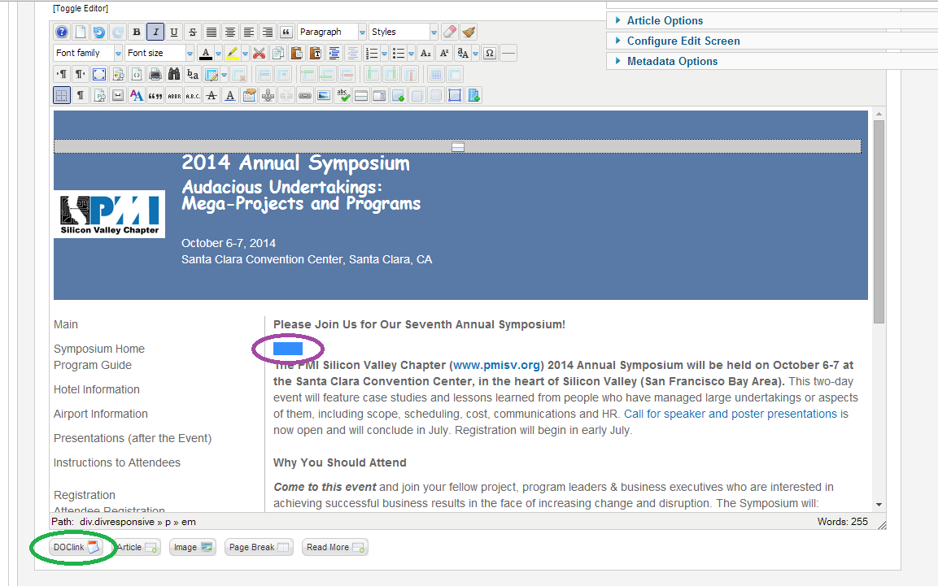
- Open the article in which you want to add this document from “Content Article Manager” menu item.
- Keep the cursor at the place where you want the document link to be added in the article / web page.
- Click the “DOClink” icon below the article text box which will open a dialog box.
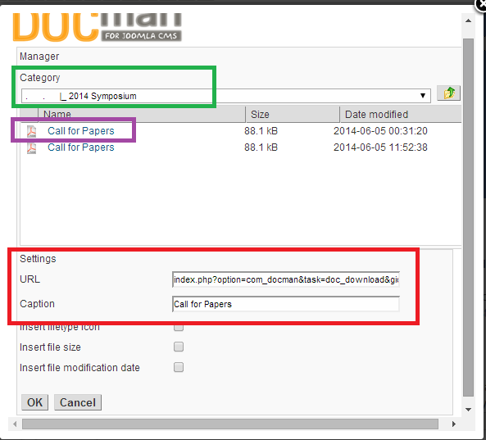
- Select the “category / folder” in which you saved the document.
- Click on the document for which you want to create the clink in the article.
- Insure that the settings fields are now populated correctly.
- Click “OK” and then save the article.
- Go to www.pmisv.org; open the correct webpage (e.g. 2014 Symposium) and insure that you see the “link” for downloading the document.
- Click on the link to insure that you are able to download the document from the website.

