Creating an Event on www.pmisv.org calendar:

- Login to http://www.pmisv.org/administrator/
- Go to JEvents under the Components tab.

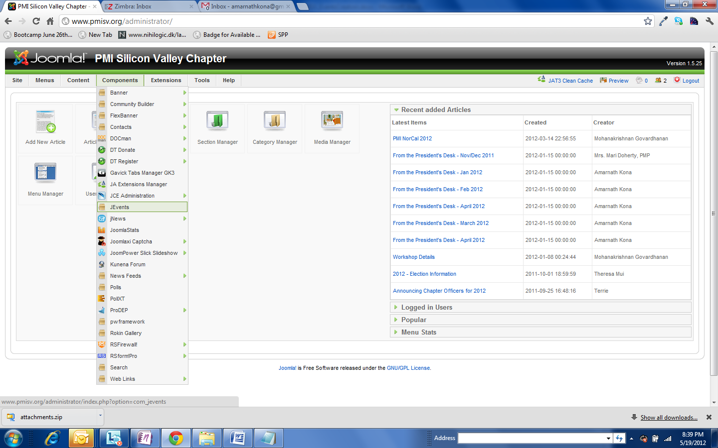

- Go to Manage Events

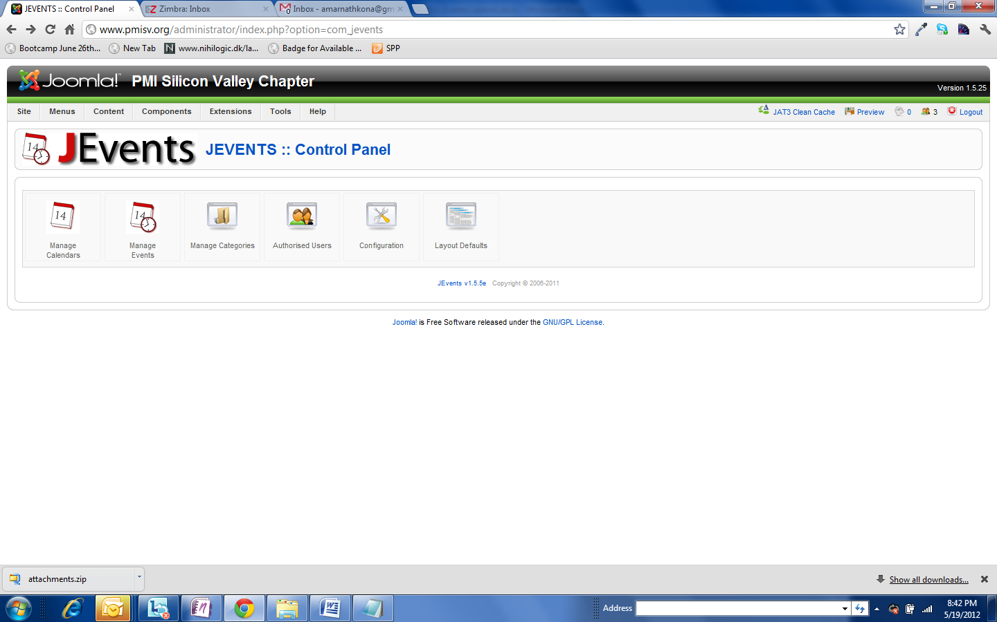

- Search for the specific event to be created from the events dropdown (in combination with Hide Past Events) and use the copy+edit option to create a copy of it before editing. It is important to copy the event to be created as the templates are different for evening program, career management seminar, career development workshop tools and techniques and breakfast event.
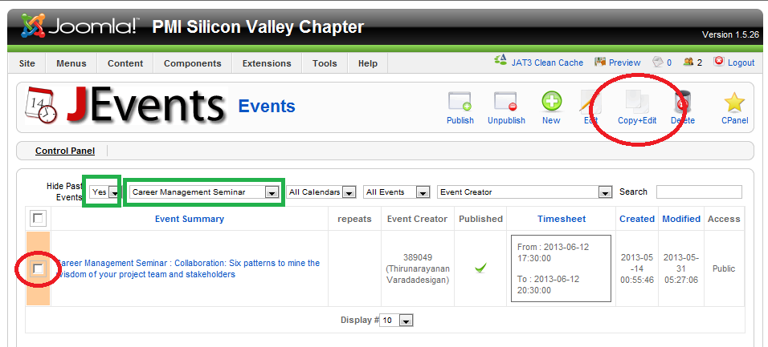

- Make changes to the copy of the event and click on Apply Changes
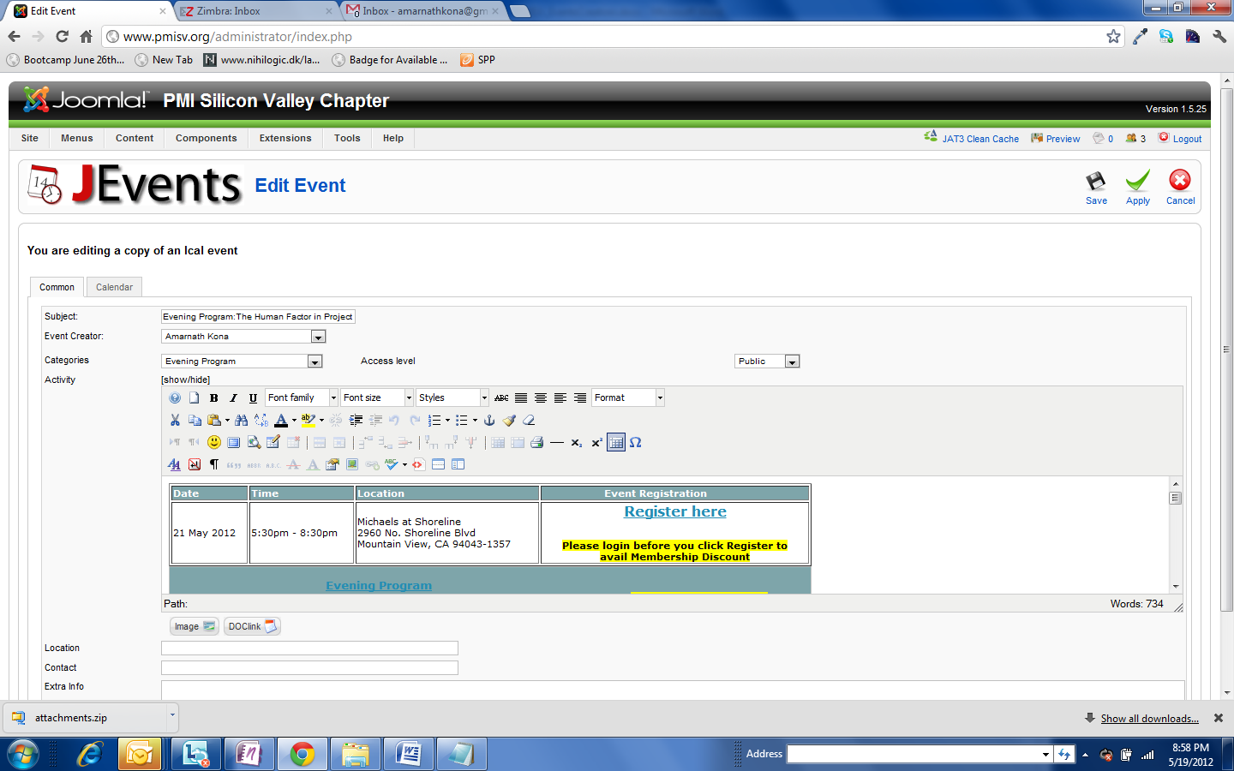

5a) For updating image(s): Copy the images from the email to your desktop (or any other appropriate folder in your computer). Image File naming convention is “SP-FirstName_LastName” (SP is for Speaker).
5b) Click on the existing speaker image and click on the “Insert / Edit Image” link
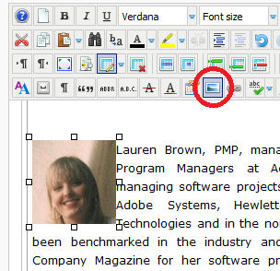

5c) In the “Image Manager” pop-up:
- Click on the “Upload” button
  - In the Upload pop-up click on “browse” and select appropriate file from your system.
  - Click on “Upload” button.
- The file should show up in the list of all files in the “Speakers” folder of Joomla. “Click” / Select the image from the list which you want to be inserted in the event. The new image should now show up in the Preview panel also.
- Select “Alignment” as Left.
- Click on the “Update” button.

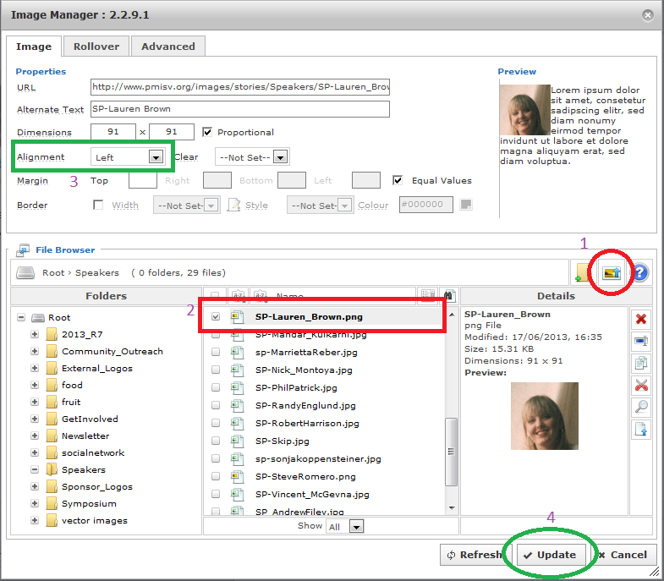
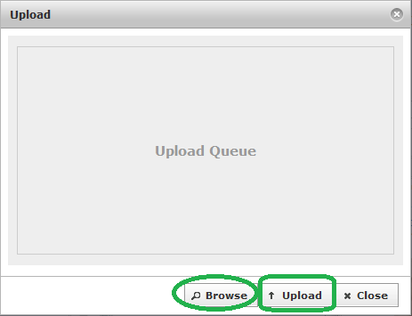

- Click on the calendar and change the date and save it. This will create it on the calendar.
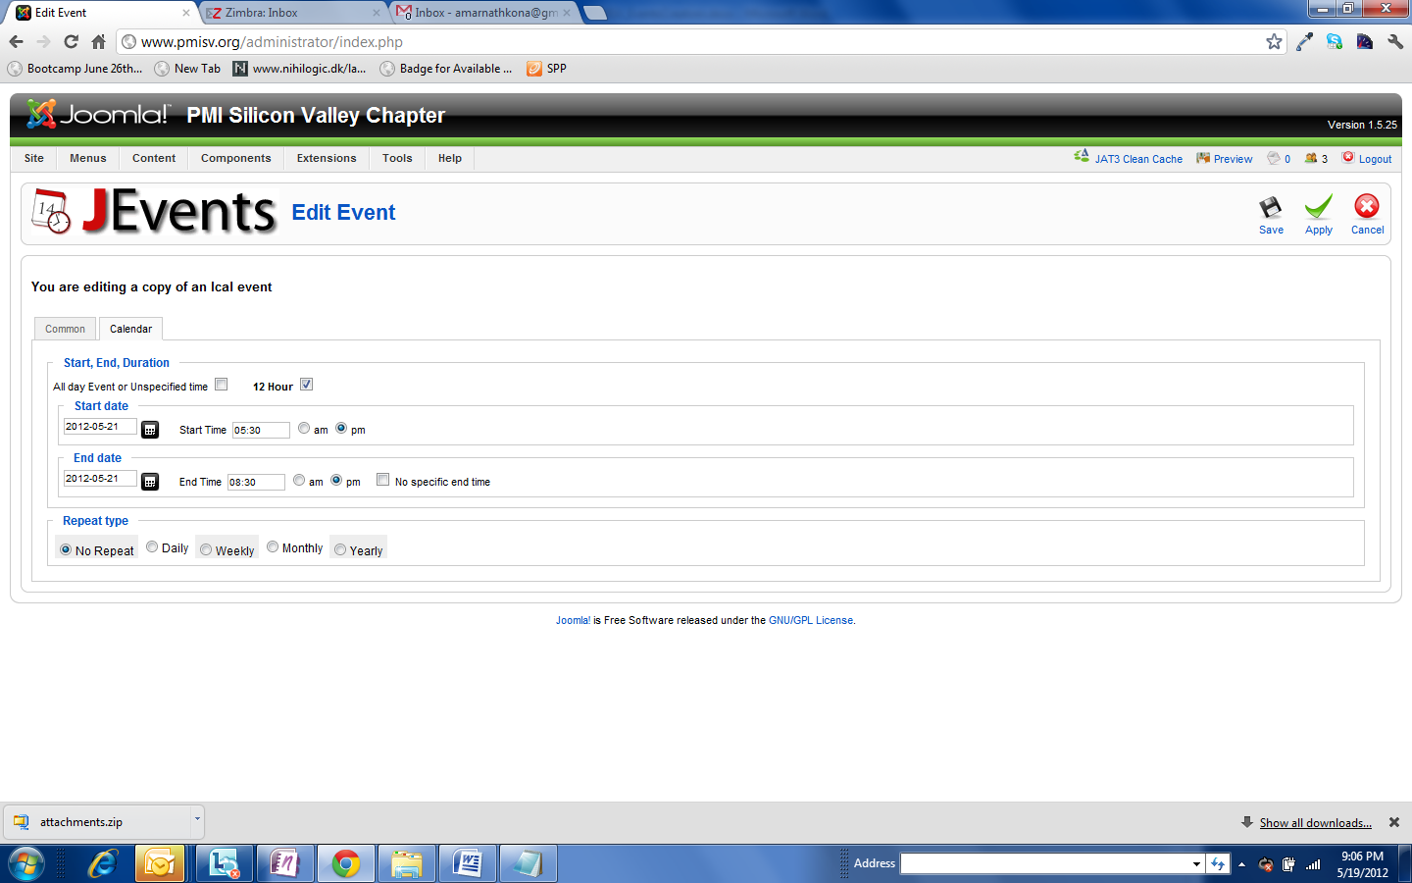

- Go to the DTRegister module to create the registration link. Go to Events under DTRegister - Events

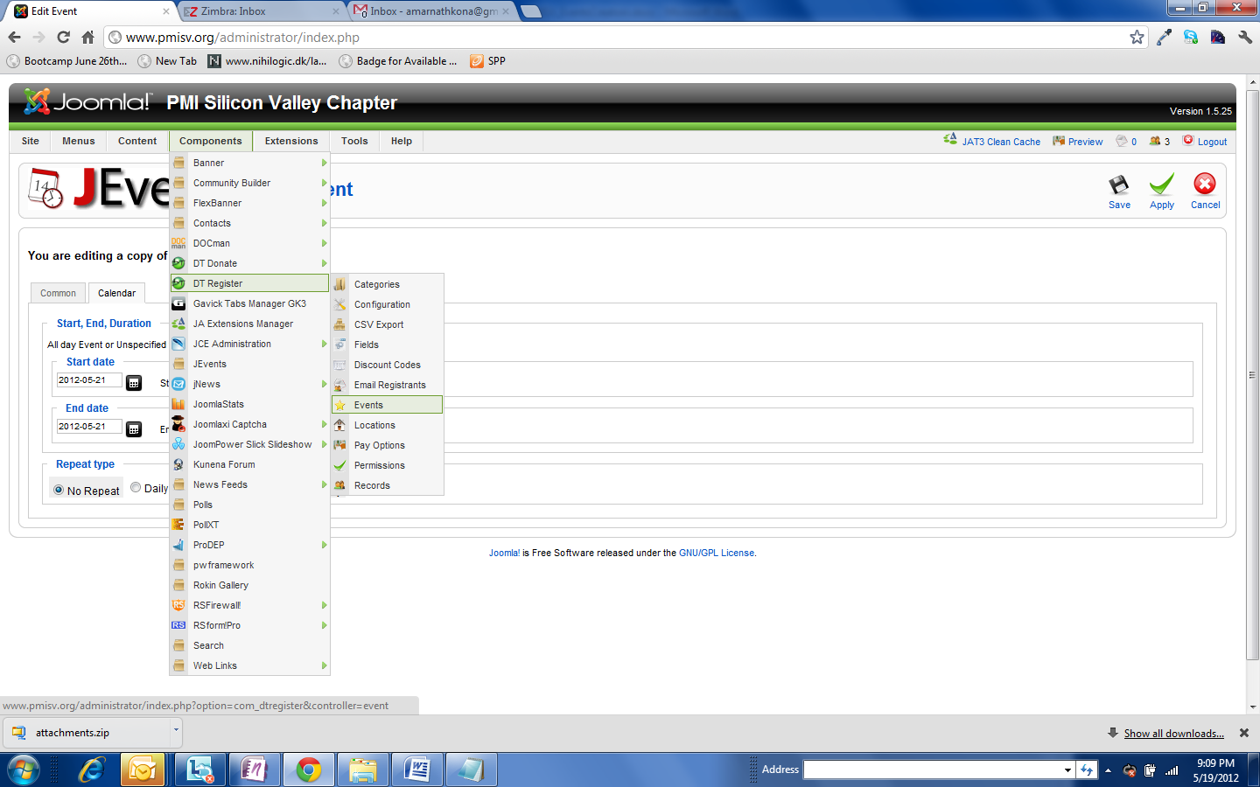
- Search for the past event and use the copy event option to create a copy of it. It is important to copy the specific event to be created
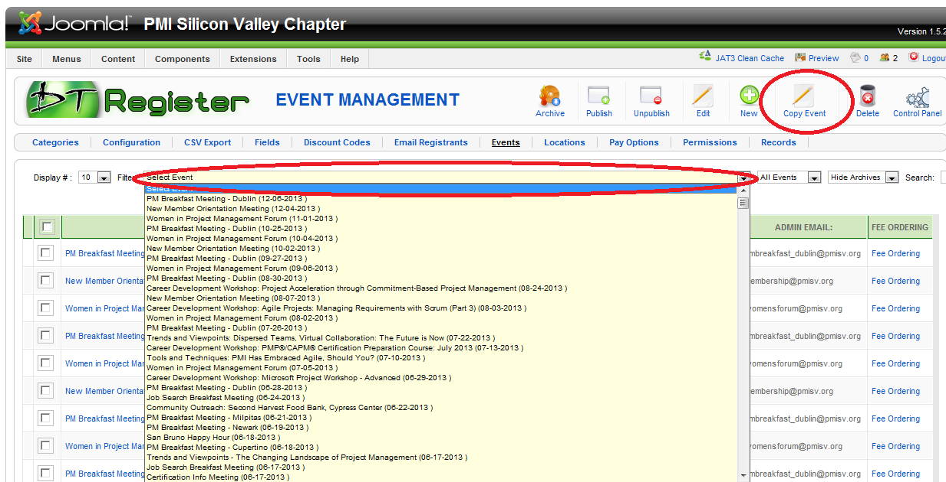

- In the copy of the event, on the general tab, information is generally changed only for 3 fields.
  - Start Date and Time
  - End Date and Time
  - Cut off Date.
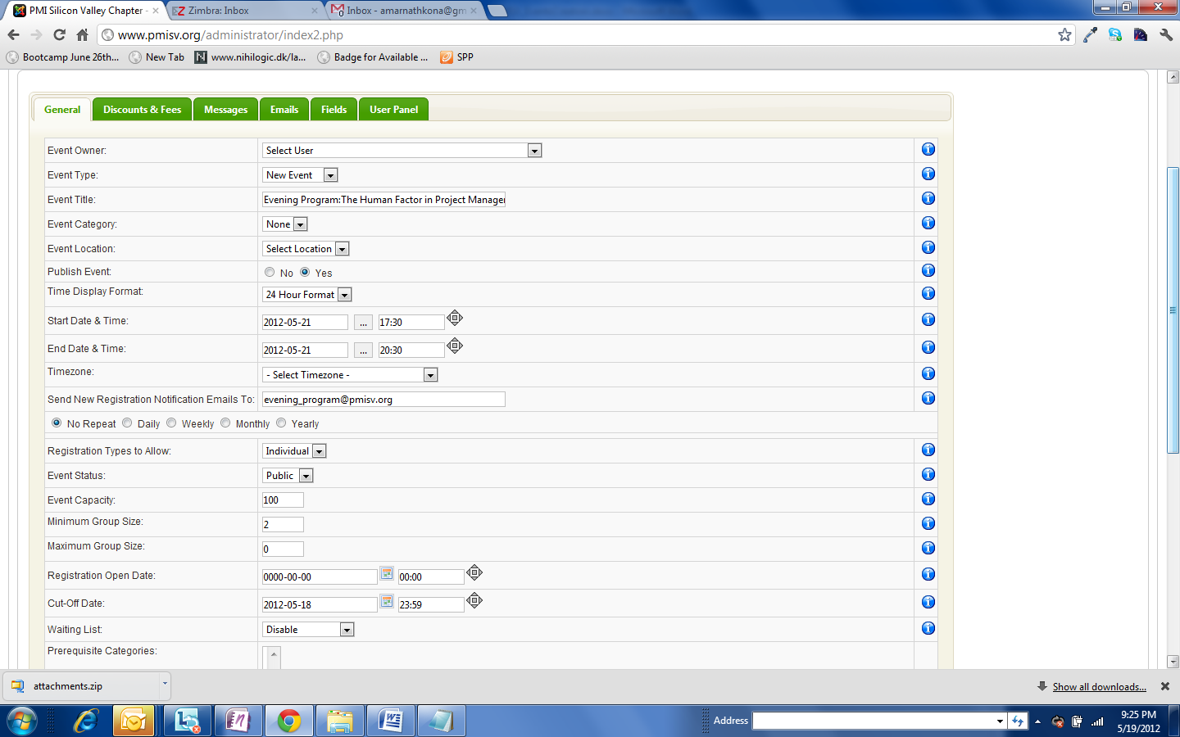

- Click on the Discounts and Fees tab.
  - Generally no change is needed when you copy for Evening Program, Tools & Techniques and Career Management Seminar unless there is a price reduction for a particular month.
  - Breakfast events are free so no change required
  - For Career Development Workshops and other special events, the price needs to be set and also early bird discount and early bird discount deadline
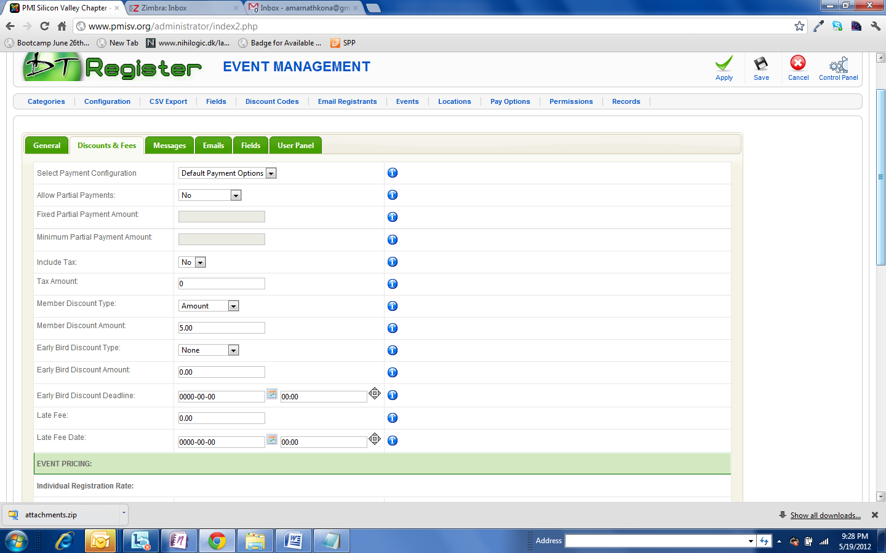

- Save the event in DTRegister and goto http://www.pmisv.org/index.php?option=com_dtregister

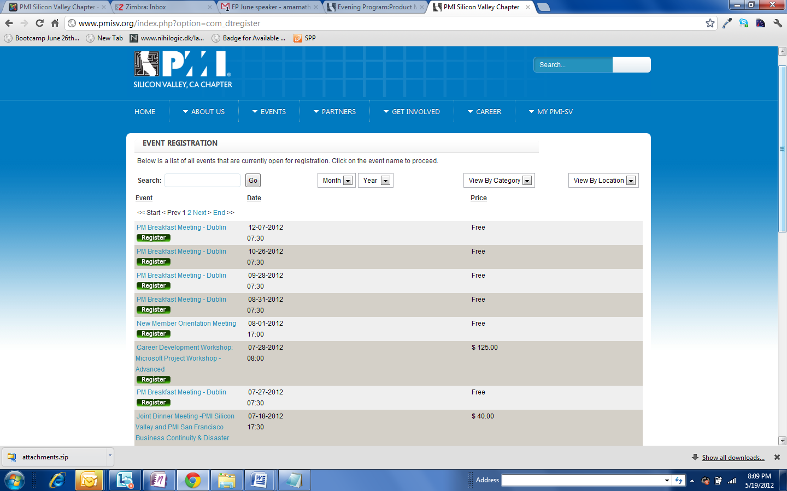
- Search for the registration created and right click on the register link and copy the link address.

- Go back to the Jevents – Event Page and edit the registration link on the event created with this registration link.
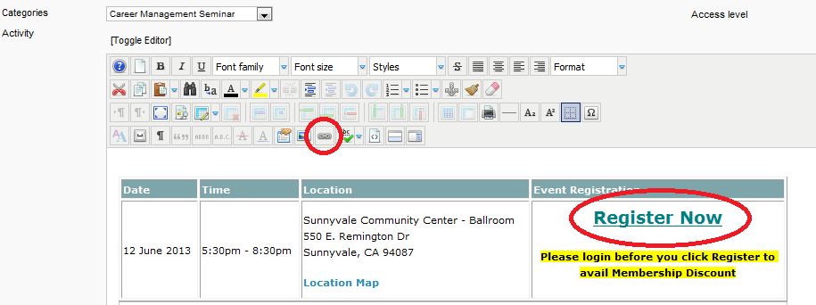

Update:
UPLOADING DOCUMENT / PRESENTATION AFTER THE EVENT IS POSTED:
- Click / Go to: Components DocMan Files
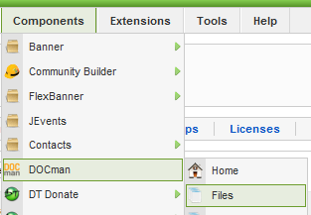
- Click on the Upload icon
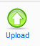
- To be completed.

