Overview

Attendee Lists are sent to the event hosts after the registration closes. As a general rule, this needs to be sent on the morning the day after the registration closes, as the hosts need this information for the event logistics. The email needs to contain the CSV file and date/type of event only. Follow these directions for all of the major events.

Special instructions:
In the case of New Member Orientation events, which happen every other month on the 1st Wednesday of the month, before Tools and Techniques event, the list is sent on Monday night or Tuesday morning. The required parameters are: First Name, Last Name, First Event?, PMP?

The reminder to send the attendee list is added to the PMISVorg@gmail.com event calendar by the IT Director right after the event is created in the pmisv.org online calendar, together with the newsletter reminder items.

The lists are sent to the following hosts:
(* Please copy vp_programs@pmisv.org for all these emails. )
Trends and Viewpoints (Evening Program) – Karol Jurado <karol.jurado@gmail.com>; "VP Programs" <vp_programs@pmisv.org>
Career Management - "Kuntal Thakore" bkthakore@gmail.com; "Olga Vilenski" olga.vilenski@gmail.com; "Ann Zis" annzis13@gmail.com; "Gianna Wrenn" <gianna_wrenn@yahoo.com>; "VP Programs" <vp_programs@pmisv.org>
Tools and Techniques – Nicole Kim at nicole.kim@me.com, Ann Zis at Ann_Zis@amat.com, "VP Programs" vp_programs@pmisv.org.
Career Development Workshop – vp_programs@pmisv.org; "Anu Mahendran" <anoomaggie@gmail.com>
New Member Orientation - "Susan Kelleher" <susankelleherpmp.pmisv@gmail.com>, "Joan Johnsen (jojohnse)" <jojohnse@cisco.com>, "VP Programs" vp_programs@pmisv.org.
Certification Info Meeting - "Kuntal Thakore" bkthakore@gmail.com
How-to:
- Go to Components > DTRegister > CSV Export:

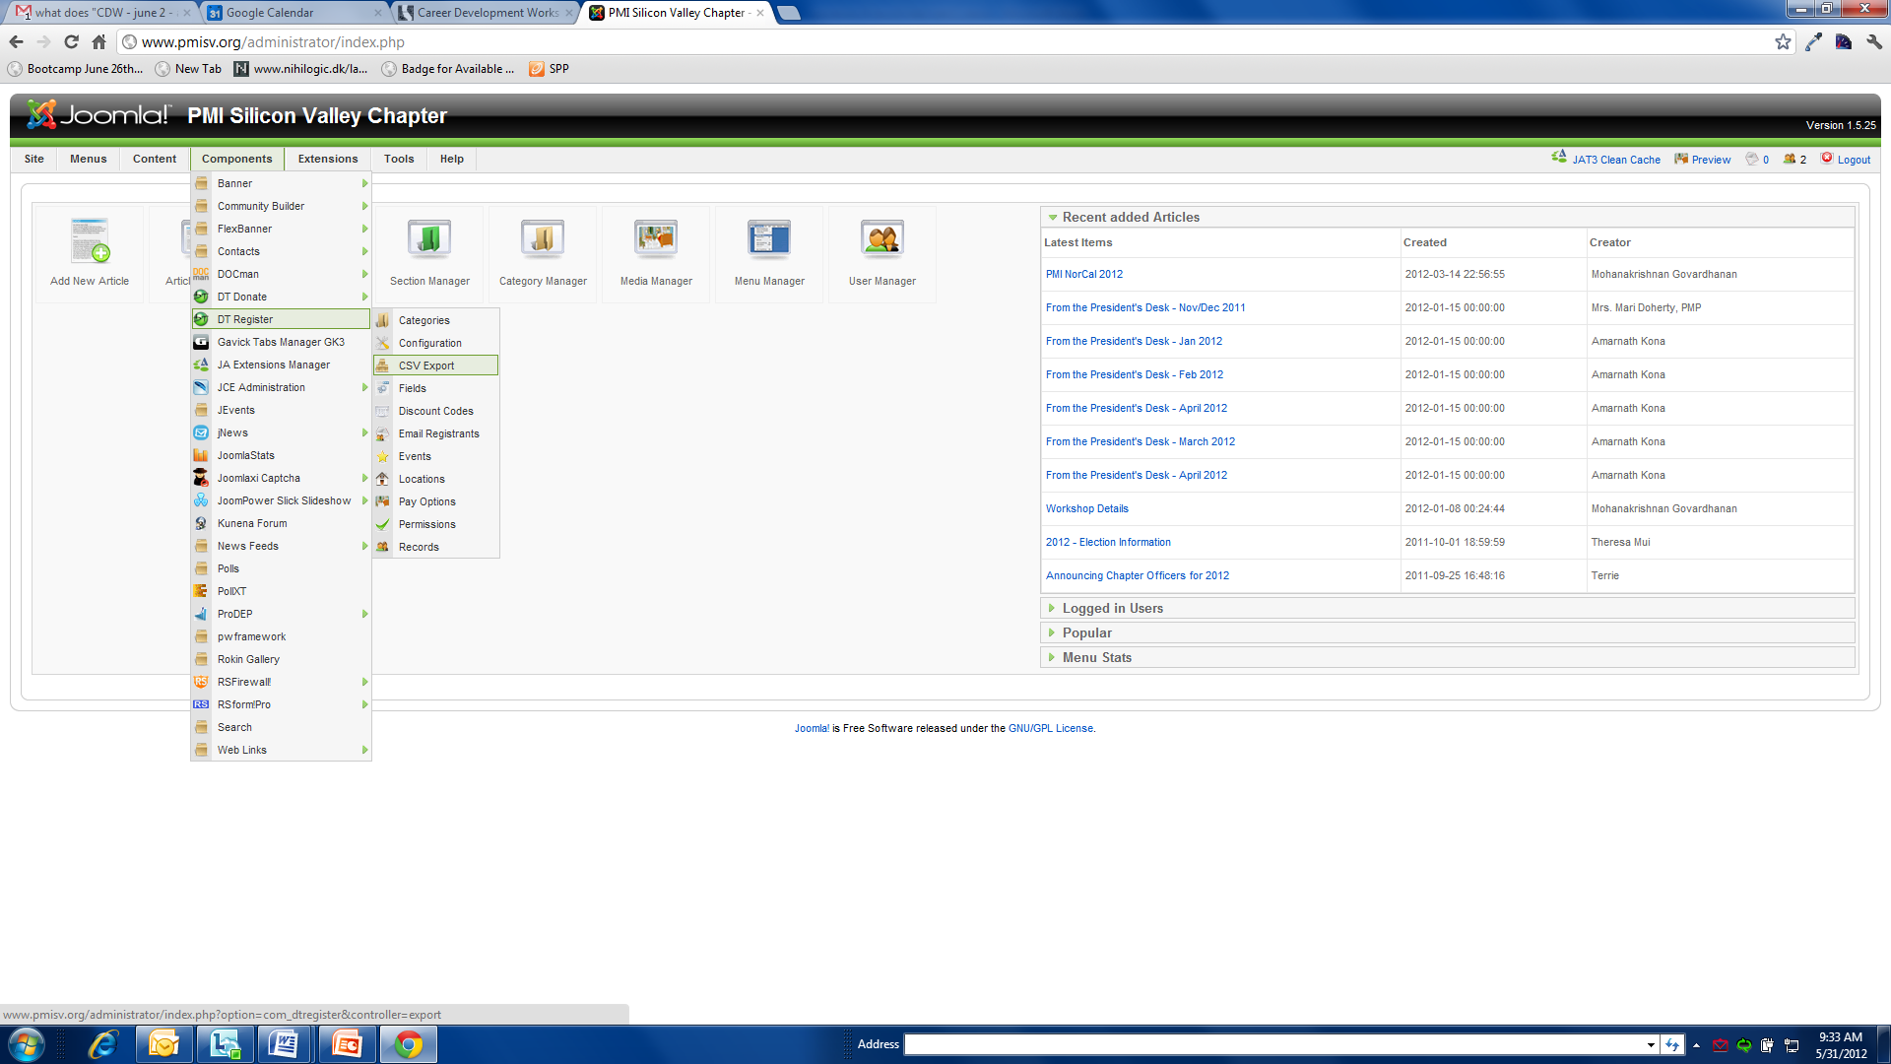
- Clear the ‘cache’ (event you previously selected is checked by default), by selecting and then de-selecting “Check All” check box.
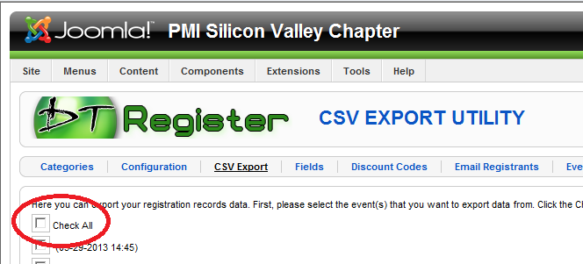
- Search for the event, by the browser text find (Ctrl+F) functionality, and select the event.
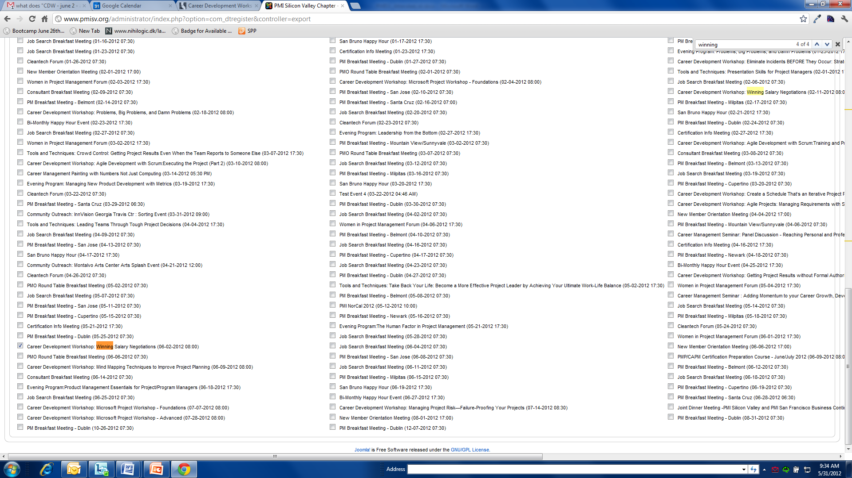
- Select the fields. The field information is mostly the same for all events except selections like “food option” which is only needed for CDW events.
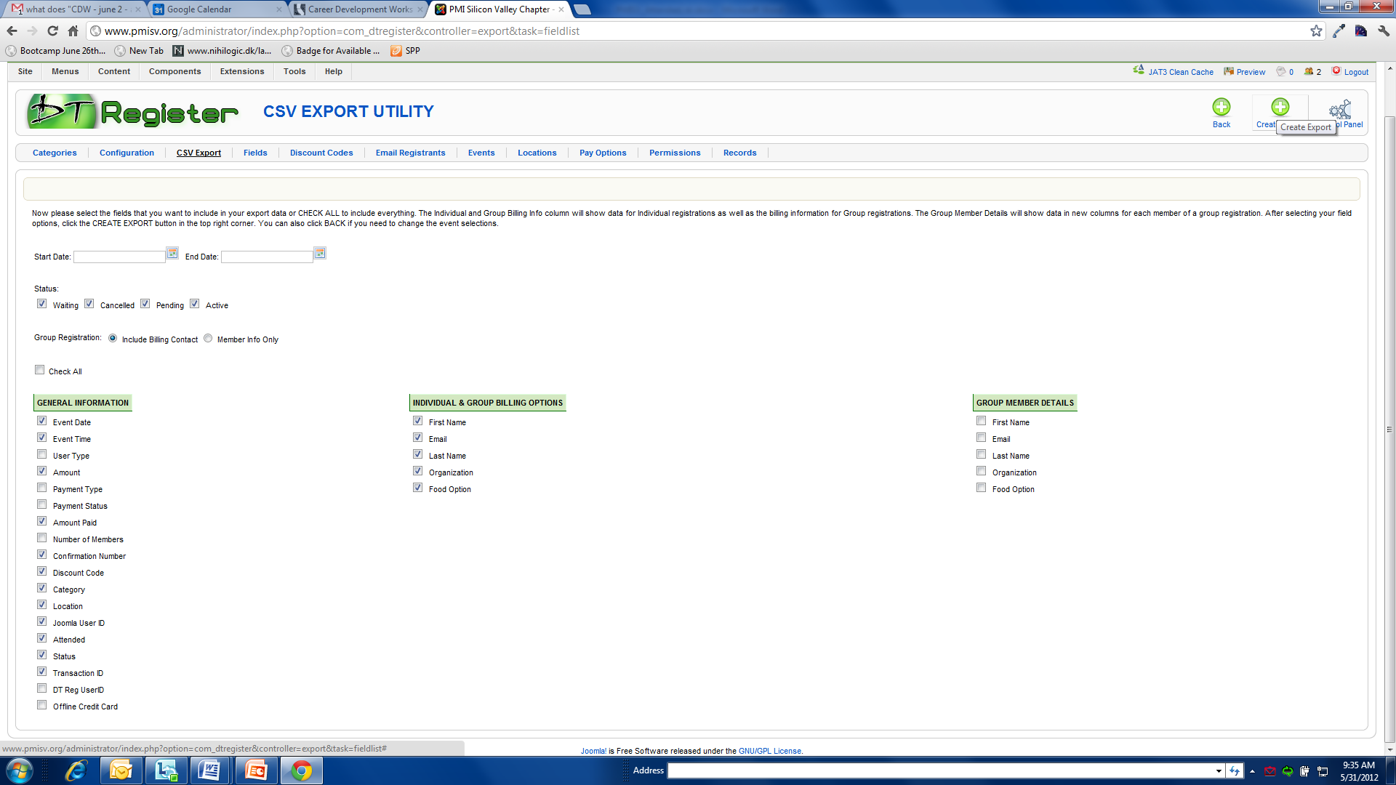

- Click on Create Export and it should create you a csv file. Default name for the created file is “BackupList_Registrations.csv”.
You can save / rename the file as “BackupList_Registrations_EventName_Date.csv”
e.g. BackupList_Registrations_CDW_Agile2_20130511.csv
- Please send the csv file to the hosts / co-hosts of the events through email.

