Overview
User Management and Subscription management are 2 different modules. A new user is created from pmi.org with all their data from pmi and a corresponding record is created in the subscription module. The evening program, career development workshop, TT, CM, special events and newsletter lists are set by default. All other lists needs to be managed by the user independently.
Please check both modules(user & subscription) to make sure the user data is correct as they can be out of sync at times.
User Management
- Select User Manager from the tab Site – User Manager

- Search for the user and select the user to edit
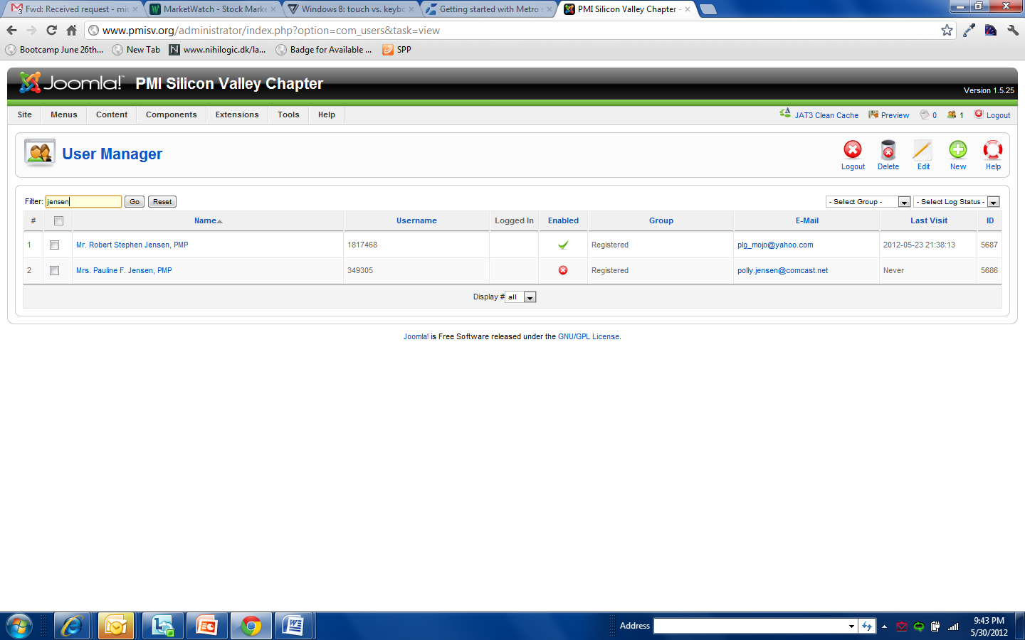

- Password reset or unblocking users are the only changes generally done in this screen. The name etc should come from pmi.org
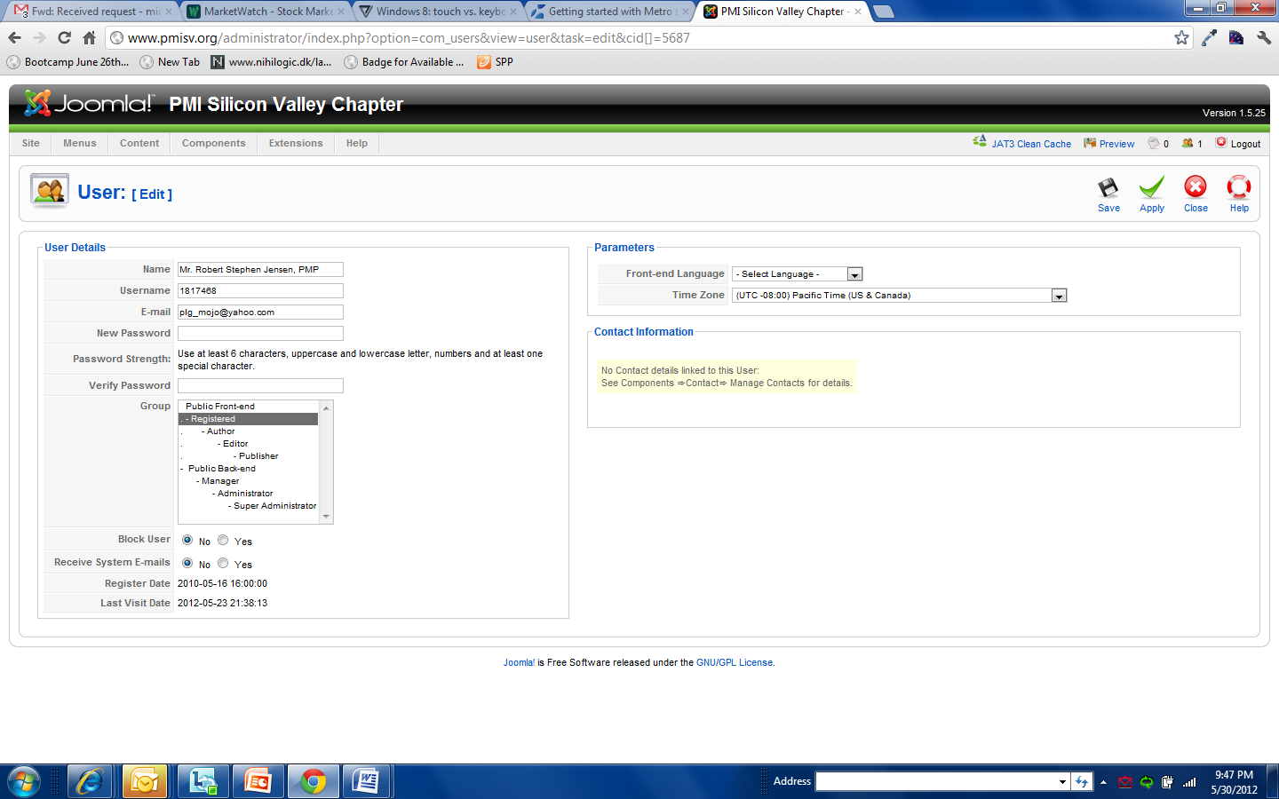

Subscription Management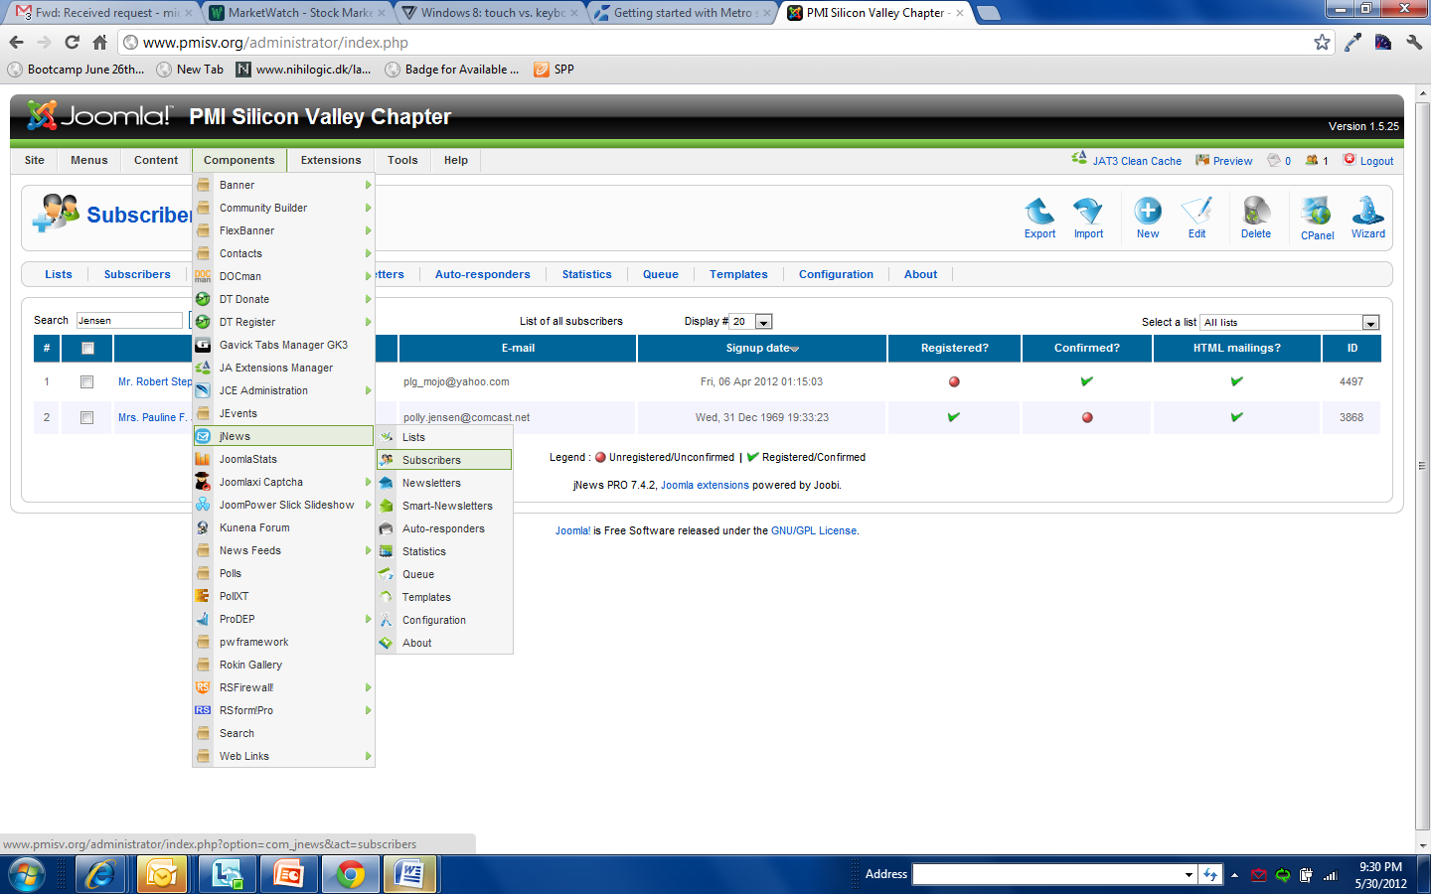

2) Click on Subscribers and search for the user you are looking for.
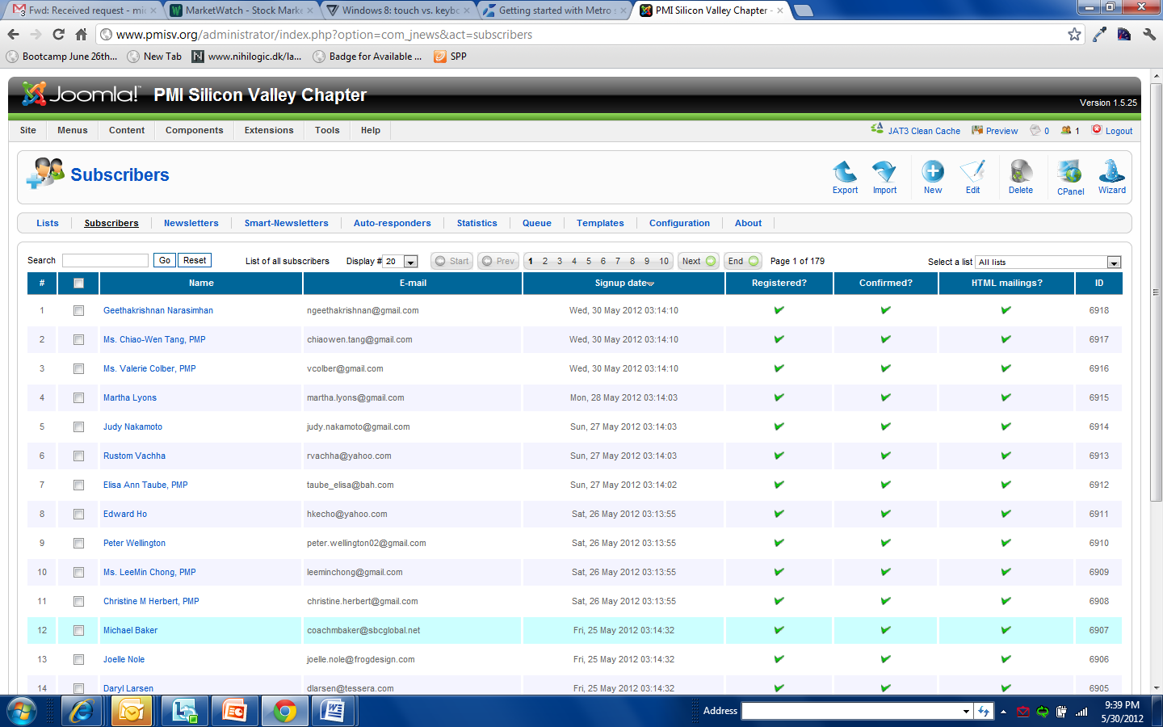

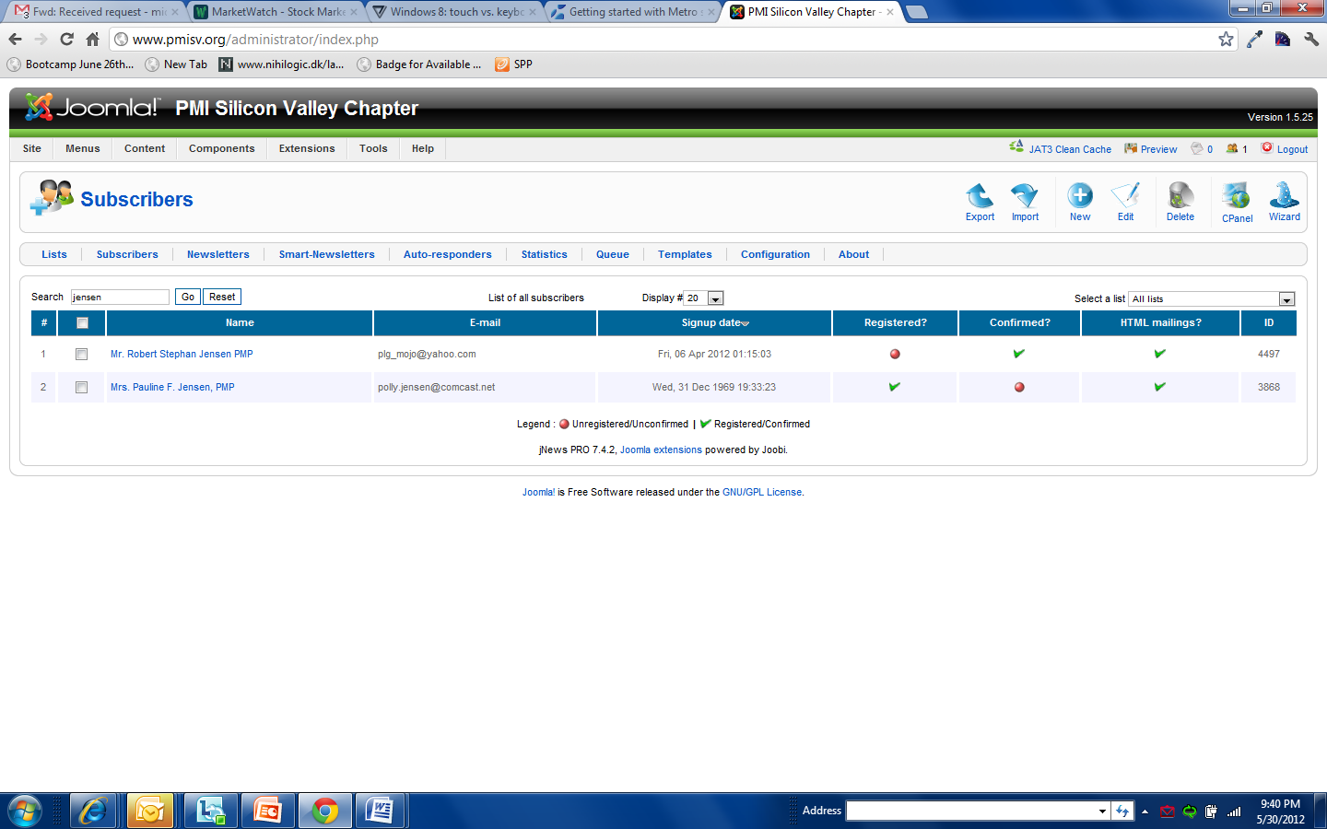
3) Select the user to make any changes.
